SESSION 08 - JOINS: INNER, LEFT, RIGHT (Foundation Session)Topics: Relationship between tables Primary / Foreign Keys INNER JOIN LEFT JOINRIGHT JOIN Demo: Join Orders + Customers ? Customer Segment? Revenue.

Answer:

Primary Key
- A Primary Key uniquely identifies every record in a table.
- Example:
user_id INT PRIMARY KEY

Foreign Key
- A Foreign Key creates a relationship between two tables.
- For example:
FOREIGN KEY(Primary_Key_of_first_Table) REFRENCE First_Table_Name(Primary_Key_of _First_Table)

INNER JOIN
- Returns only records where a matching record exists in both tables.

LEFT JOIN
- Returns all records from the left table, even when there is no matching record in the right table.

RIGHT JOIN
- Returns all records from the right table, even when there is no matching record in the left table.

JOIN Comparison

Join Type | Result
INNER JOIN | Only matching records from both tables
LEFT JOIN | All records from left table + matching records from right table
RIGHT JOIN | All records from right table + matching records from left table

Task_01
CREATE DATABASE session08_tasks
CREATE TABLE Users (
user_id INT PRIMARY KEY AUTO_INCREMENT,
username VARCHAR(50) NOT NULL,
city VARCHAR(50)
);
#Join query
CREATE TABLE Orders (
order_id INT PRIMARY KEY AUTO_INCREMENT,
user_id INT,
product VARCHAR(100),
amount DECIMAL(10,2),
FOREIGN KEY (user_id) REFERENCES Users(user_id)
);
INSERT INTO Users (user_id, username, city)
VALUES
('Hitesh', 'Ahmedabad'),
('Rahul', 'Surat'),
('Priya', 'Rajkot'),
('Amit', 'Vadodara'),
('Neha', 'Mumbai');
INSERT INTO Orders (order_id, user_id, product, amount)
VALUES
(1, 'Paneer Burger', 180.00),
(1, 'Masala Dosa', 120.00),
(2, 'Veg Pizza', 350.00),
(2, 'Cold Coffee', 90.00),
(1, 'French Fries', 100.00),
(4, 'Veg Biryani', 250.00),
(4, 'Lassi', 80.00),
(5, 'Cheese Sandwich', 200.00);

Task_02

CREATE VIEW Inner_join AS
SELECT users.username,orders.product,orders.amount
FROM users
INNER JOIN orders
ON users.user_id = orders.order_id

Output
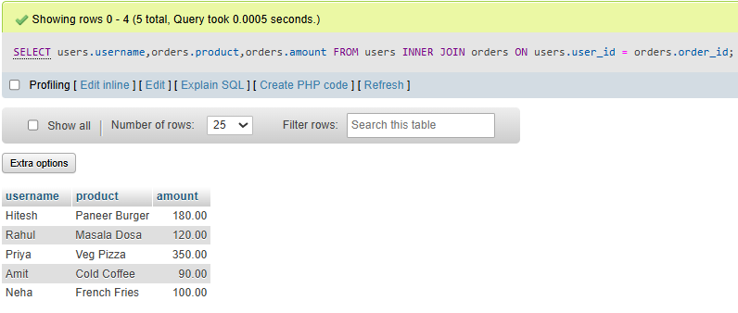

Tasks_03
CREATE VIEW Left_join AS
SELECT users.username,orders.product,orders.amount
FROM users
LEFT JOIN orders
ON users.user_id = orders.order_id

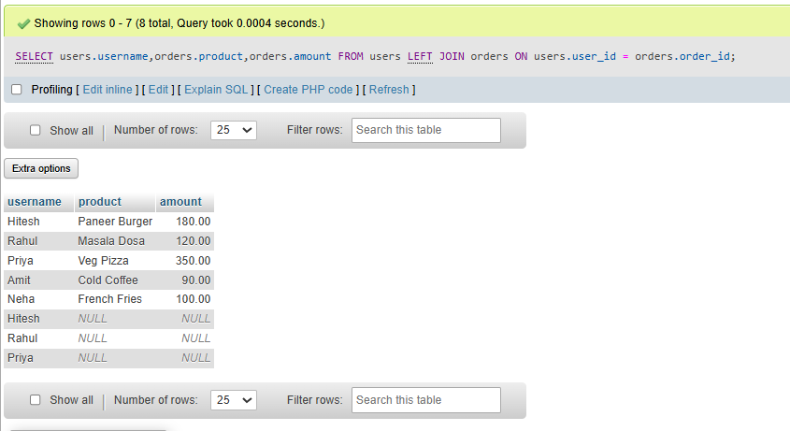
Output

Task_04
Suppose you want to analyze food delivery data like Zomato. Create a CustomerSegments table (segment_id, segment_name), and link it to Users with a foreign key. Write an SQL query to show each username, their segment name, and total order amount (use JOINs as needed).
CREATE VIEW Right_join AS
SELECT users.username,orders.product,orders.amount
FROM users
RIGHT JOIN orders
ON users.user_id = orders.order_id

Output

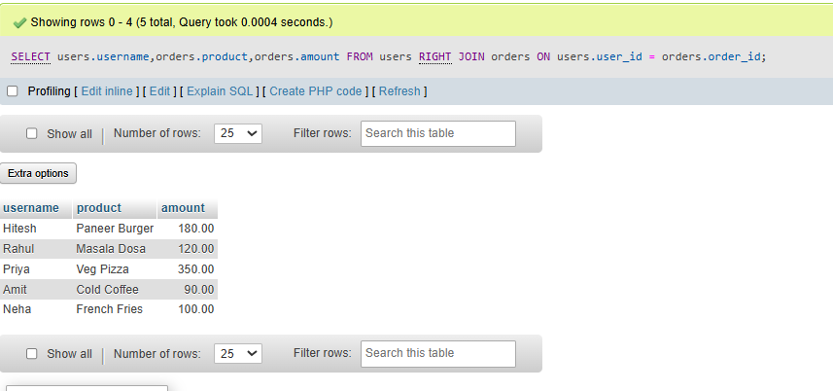

Task_05
CREATE TABLE CustomerSegments (
segment_id INT PRIMARY KEY AUTO_INCREMENT,
segment_name VARCHAR(50) NOT NULL
);
INSERT INTO CustomerSegments (segment_name)
VALUES
('Premium'),
('Regular'),
('New');
ALTER TABLE Users
ADD COLUMN segment_id INT;
ALTER TABLE Users
ADD COLUMN segment_id INT;
ALTER TABLE Users
ADD CONSTRAINT fk_user_segment
FOREIGN KEY (segment_id)
REFERENCES CustomerSegments(segment_id);
UPDATE Users
SET segment_id = 1
WHERE user_id = 1;
UPDATE Users
SET segment_id = 2
WHERE user_id = 2;
UPDATE Users
SET segment_id = 3
WHERE user_id = 3;

SELECT
users.username,
customersegments.segment_name,
COALESCE(SUM(orders.amount), 0) AS total_order_amount
FROM Users
INNER JOIN CustomerSegments
ON users.segment_id = customersegments.segment_id
LEFT JOIN Orders
ON users.user_id = orders.user_id
GROUP BY
users.user_id,
users.username,
customersegments.segment_name
ORDER BY
total_order_amount DESC;

Output
